Use Kubernetes service accounts to enable automated kubectl access

Introduction:
In Kubernetes, every API request must be authenticated and authorized. By default, administrators use their own kubeconfig files to authenticate with full privileges — but in many cases, we need to give limited access to specific users, applications, or automation systems.
This is achieved using Service Accounts and RBAC (Role-Based Access Control).
This project demonstrates how to:
- Create a ServiceAccount for limited access.
- Define a Role with specific permissions (to manage pods).
- Bind them with a RoleBinding.
- Create and use a custom kubeconfig that authenticates as that ServiceAccount.
The final result is a dedicated kubeconfig file that can be used to run kubectl commands as that service account with restricted permissions.

Objectives
The main goals of this project are:
- Understand ServiceAccounts and their role in Kubernetes security.
- Configure RBAC using Roles and RoleBindings.
- Generate a service account token and use it for authentication.
- Test permissions using a custom Kubeconfig file.

Key Concepts:
Service Account (SA):
A Service Account is a special type of account used by:
- Pods running inside the cluster (for in-cluster API calls), or
- External automation tools (CI/CD, scripts) to authenticate with the API server.

Unlike normal user accounts, service accounts are namespaced and managed by Kubernetes itself.
Each service account has:
- A name (e.g., myexample-sa)
- A namespace (e.g., myexample)
- An associated token used for authentication

RBAC (Role-Based Access Control)
RBAC defines who can do what within the cluster.
It uses 4 key Kubernetes objects:
- Role: Defines permissions within a specific namespace.
Ex: View pods, get services, etc.
- ClusterRole: Defines cluster-wide permissions.
Ex: View all pods in all namespaces.
- RoleBinding: Grants a Role to a user or service account within one namespace.
Ex: Bind Role to myexample-sa
- ClusterRoleBinding: Grants a ClusterRole to a user or service account cluster-wide.
Ex: Bind ClusterRole view to myexample-sa.

Example:
- Role = What actions are Allowed?
- RoleBinding = Who gets those permissions?

Tokens and Kubeconfig
When you create a ServiceAccount, Kubernetes issues a JWT token that allows API access.
By embedding this token in a Kubeconfig file, you can use kubectl commands as that service account — without administrator privileges.

This helps in:
- Running automation tasks securely.
- Delegating limited access to developers or CI/CD pipelines.
- Following the principle of least privilege.

Implementation Steps:
Step1: Create a Namespace
By creating a namespace called myexample, you ensure that your ServiceAccount and Roles are scoped — meaning, they can’t accidentally affect other namespaces.
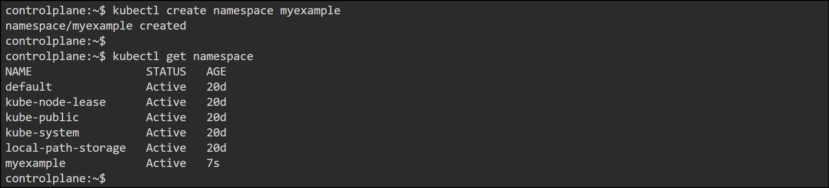

Step2: Create a Service Account
A ServiceAccount represents a non-human user in Kubernetes. When created, Kubernetes associates it with a unique name and optionally a token (a JWT used for authentication).
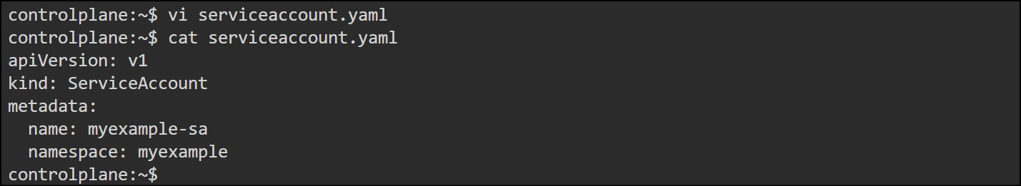

Apply it
kubectl apply -f serviceaccount.yaml

Verify:
Kubectl -n myexample get sa
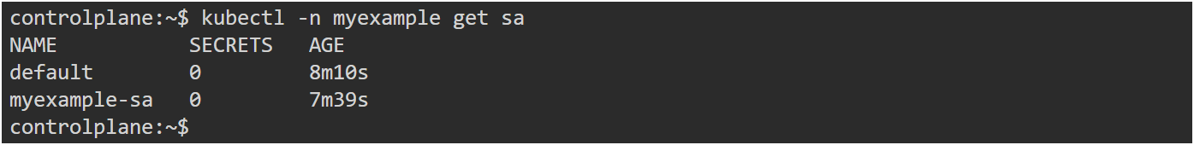

Step3: Create a Role
role.yaml
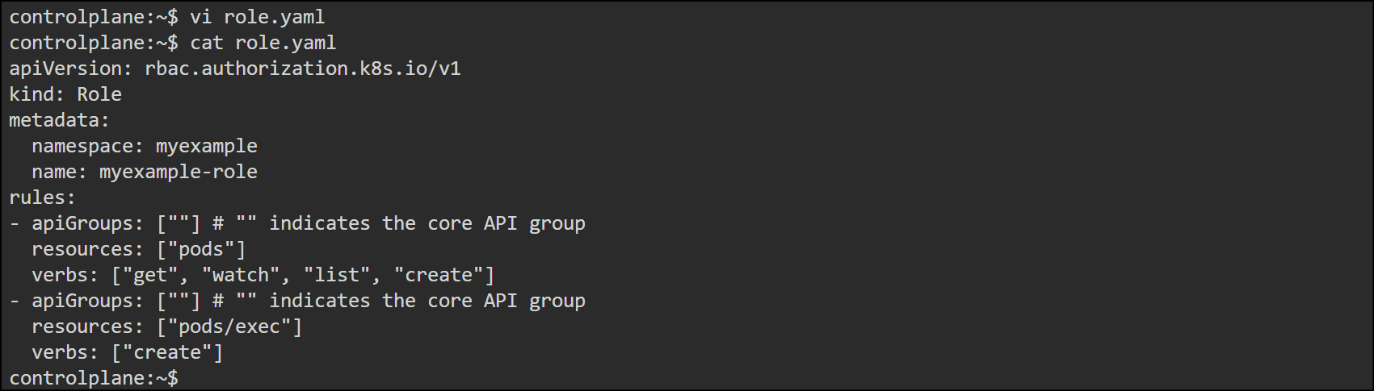

Apply it
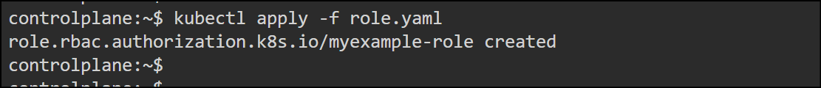
A Role defines what actions (verbs) can be performed on which resources in a specific namespace.

Verify:
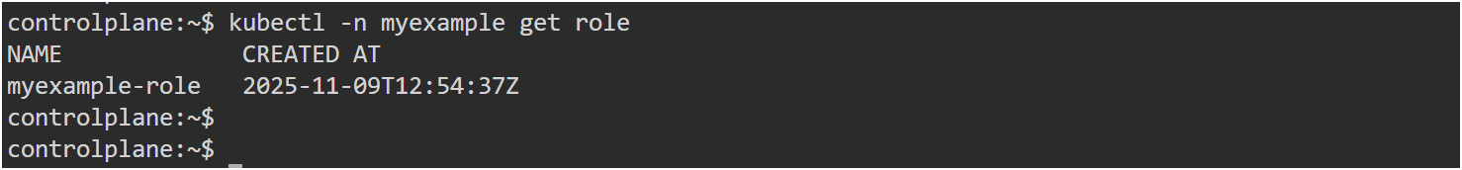

Step4: Create RoleBinding
rolebinding.yaml
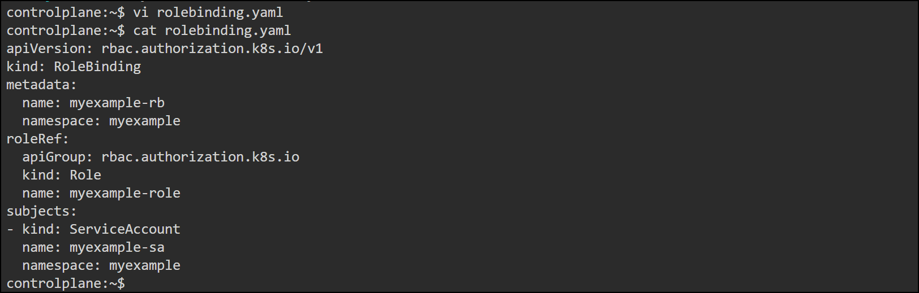

Apply it

Verify
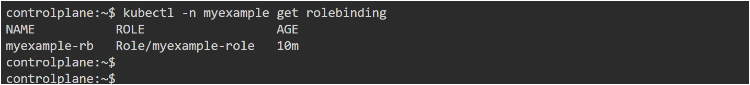

Step5: Create Token for the Service Account
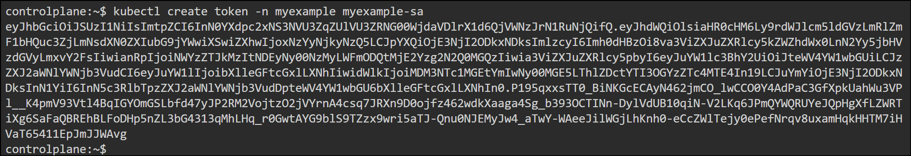
Copy this token — it’s your authentication key.

Step6: Get Cluster Server URL
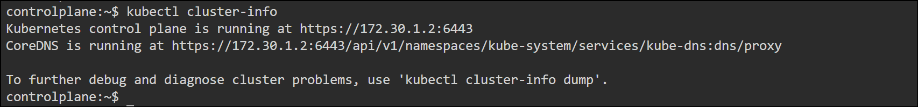

Step7: Create Custom Kubeconfig
sa-kubeconfig.yaml
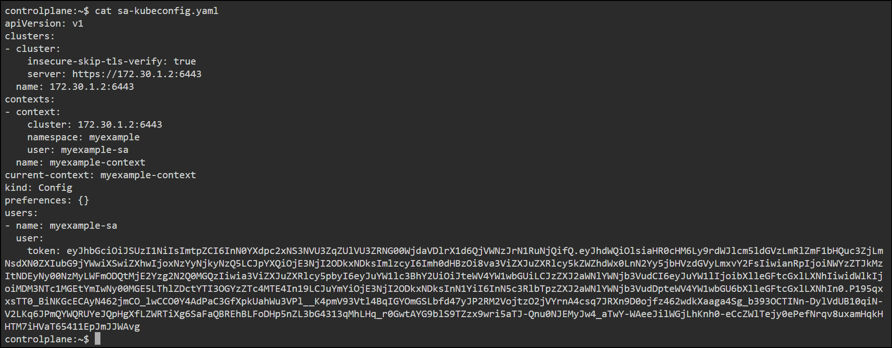
Replace the token value with your real token from Step 5.
Save and exit

Step8:Test the Kubeconfig

Lists Pods in the namespace

Try creating a pod (you’re allowed per your Role):

You’ll see
pod/testpod created

Step9: Validate Access Control
Check what this SA can do:
Output: yes

Try deleting a pod (not permitted):
Output: No

Advantages of Namespace-Scoped RBAC
- Least Privilege: Limits access to only needed actions.
- Namespace Isolation: Prevents cross-namespace access.
- Automation Safe: Ideal for scripts or CI/CD jobs.
- Auditable: Each API call is logged under the service account identity.

Conclusion:
This configuration provides a secure, minimal-permission access model for Kubernetes.
By combining ServiceAccounts, Roles, and RoleBindings, administrators can precisely control what workloads or users can do within each namespace.
Finally, the custom Kubeconfig allows external tools and automation systems to access Kubernetes APIs safely.

